Evaluation Warning: The document was created with Spire.Doc for Python.



**Mystical Madhya Pradesh: A Spiritual Journey**

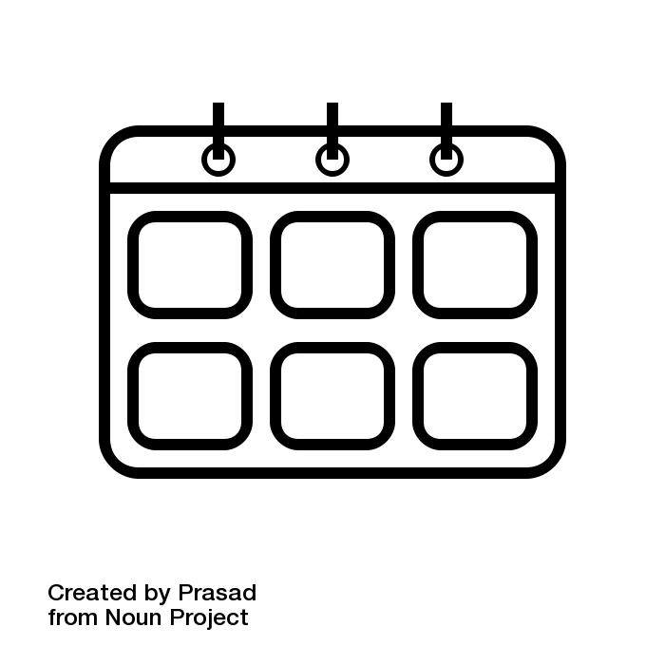 Number of Days : 1

 Budget Per Person : Rs. 10000

 Cities : Ujjain, Omkareshwar, Maheshwar, Indore, Bhopal



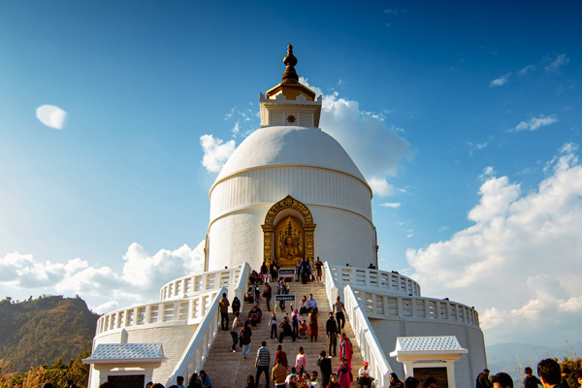

**Day 1: Tranquil Temples and Spiritual Serenity in Ujjain**

Travel Time: Approximately 8 hours  
Travel Distance: 620 km  
  
As we embark on our spiritual journey to Madhya Pradesh, we will start our day by boarding a comfortable bus from Mumbai to Ujjain. Upon our arrival in Ujjain, known for its ancient temples and spiritual significance, we will visit the Mahakaleshwar Temple and experience the mesmerizing evening aarti. We will explore the serene surroundings and immerse ourselves in the spiritual aura of this sacred city. Later, we will enjoy a delicious dinner before retiring for the night.





**Day 2: Sacred Sites and Scenic Beauty in Omkareshwar**

Travel Time: Approximately 4 hours  
Travel Distance: 140 km  
  
After a restful night in Ujjain, we will head to Omkareshwar, a picturesque island temple town. We will visit the Omkareshwar Temple, dedicated to Lord Shiva, and seek blessings for our journey ahead. We will also explore the surrounding natural beauty, including the scenic Narmada River. In the afternoon, we will enjoy a leisurely boat ride and savor a traditional lunch by the riverside. Later, we will continue our journey to the historic town of Maheshwar.



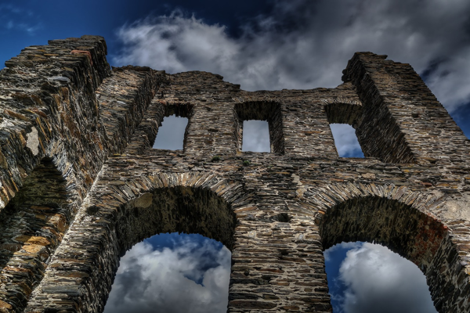

**Day 3: Cultural Heritage and Riverside Splendor in Maheshwar**

Travel Time: Approximately 2 hours  
Travel Distance: 90 km  
  
In Maheshwar, known for its rich heritage and architectural marvels, we will visit the majestic Maheshwar Fort and admire the intricate carvings and stunning views of the Narmada River. We will explore the charming lanes of the town, shop for traditional handloom sarees, and indulge in delectable local cuisine. In the evening, we will witness the grand Narmada Aarti at the ghat and immerse ourselves in the spiritual atmosphere. After a fulfilling day, we will proceed to our next destination, Indore.



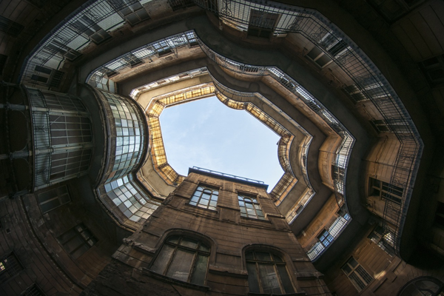

**Day 4: Culinary Delights and Cultural Experiences in Indore**

Travel Time: Approximately 2.5 hours  
Travel Distance: 100 km  
  
Our day in Indore will be filled with culinary delights and cultural experiences. We will start by visiting the iconic Rajwada Palace, a symbol of the city's rich history. We will explore the vibrant Sarafa Bazaar and indulge in street food delicacies. After a satisfying lunch, we will visit the Kanch Mandir, a Jain temple known for its intricate glasswork. In the evening, we will relax at the scenic Pipliyapala Regional Park and enjoy the musical fountain show. Later, we will proceed to our final destination, Bhopal.



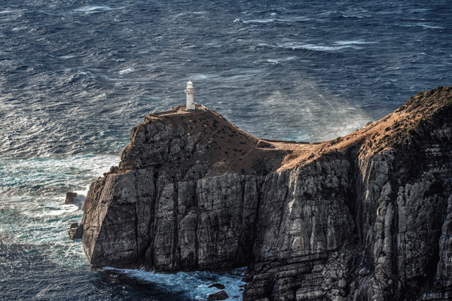

**Day 5: Historical Sites and Architectural Wonders in Bhopal**

Travel Time: Approximately 3 hours  
Travel Distance: 190 km  
  
Our last day in Madhya Pradesh will be spent exploring the historical sites and architectural wonders of Bhopal. We will visit the UNESCO World Heritage Site of Bhimbetka Rock Shelters and marvel at the ancient rock paintings. We will then proceed to the iconic Taj-ul-Masajid, one of the largest mosques in India, and admire its stunning architecture. In the evening, we will stroll around the serene Upper Lake and witness the beautiful sunset. Finally, we will conclude our spiritual journey and head back to Mumbai with cherished memories and divine blessings.

Evaluation Warning: The document was created with Spire.Doc for Python.



Acommodation Details

|  |  |  |
| --- | --- | --- |
| City | Hotel | Price |
|  |  | 0 |

Local Transport Details

|  |  |  |
| --- | --- | --- |
| City | Car | Fare |
|  |  | 0 |



**INCLUSIONS:**

* Accommodation on twin/triple sharing basis.
* All interstate taxes, permits, parking, road tax, toll taxes and fuel charges etc included.
* All government applicable taxes and service charges.

**EXCLUSIONS:**

* Personal expenses such as laundry, telephone calls, tips, liquor, boating & joy rides.
* All kind of personal expenses such as tips, laundry, telephone bills and beverages, Camera Fees.
* Cable Car Tickets, Any meals unless and otherwise specifically mentioned.
* Any claim due to road blocks, curfew, accident etc.
* Any other items which not specified in “Cost Inclusions”.